**Модель «Трактор»**

|  |  |
| --- | --- |
| 20190307_125455.jpg1 | 20190307_125446.jpg  2 |
| 20190307_125438.jpg  3 | 20190307_125423.jpg  4 |
| 20190307_125416.jpg  5 | 20190307_125403.jpg  6 |
| 20190307_125413.jpg7 | 20190307_125336.jpg8 |
| 20190307_125309.jpg  9 | 20190307_125236.jpg  10 |
| 20190307_125131.jpg  11 | 20190307_125119.jpg  12 |

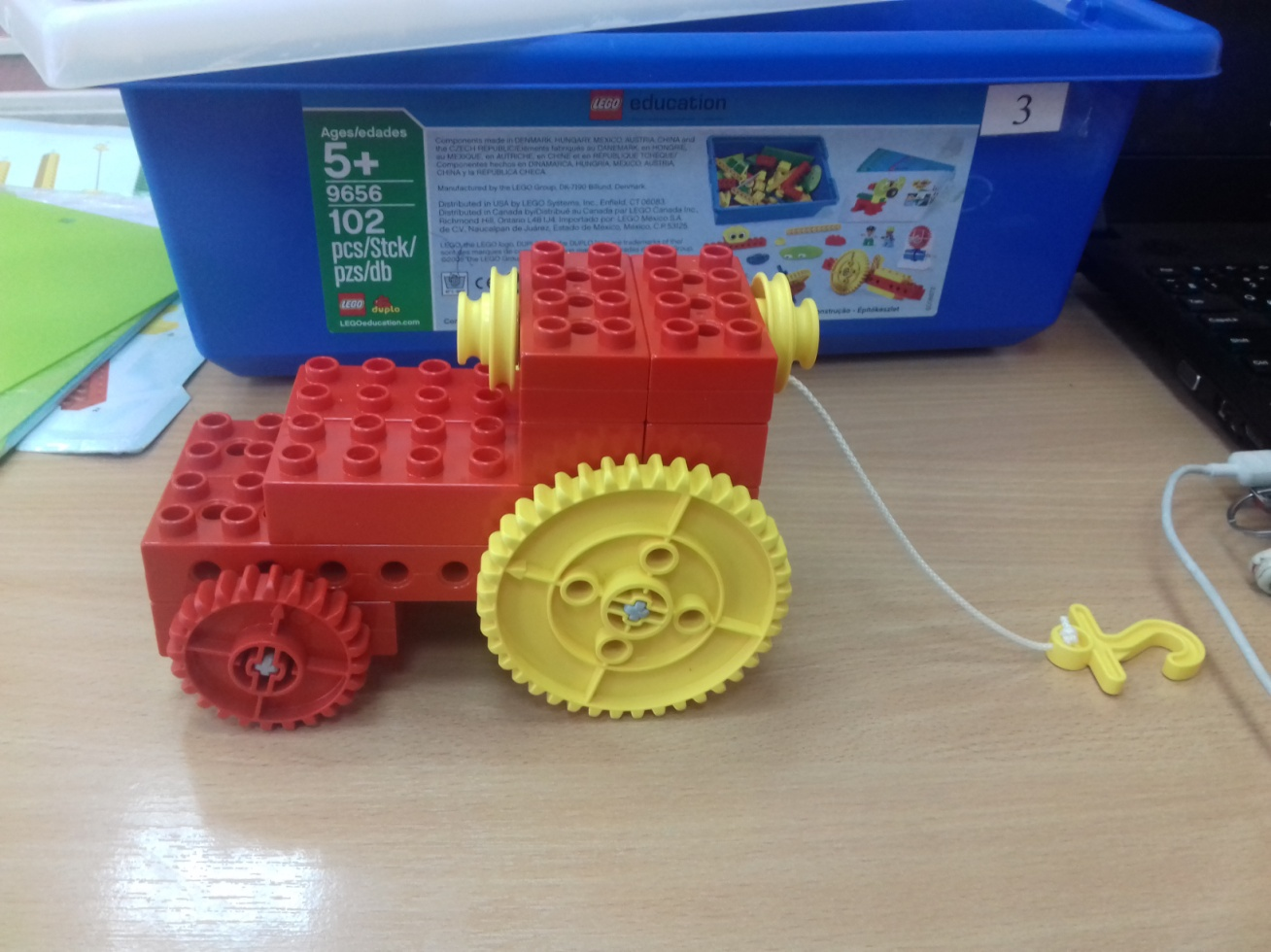

13